

E-Police

Management

System

**PC MOHLALA 201996898**

**SJ LETOABA 201911299**

**NW TSHIVHULA 201931796**

**Z SEBELA 202000532**

**T TSOTSETSI 219085633**

**K POOE 219056218**

**Chapter 4: System Design Document**

Document Overview

The System Design Document (SDD) explains how the functional and non-functional requirements in the Requirements Document, the preliminary user-oriented functional design in the High-Level Technical Design Concept/Alternatives document, and the preliminary data design in the Logical Data Model (LDM) become more technical system design specifications from which a system can be built. The SDD contains both high-level and detailed system design specifications.

The SDD describes design goals and considerations, provides a high-level overview of the system architecture, and describes the data design associated with the system, as well as the human-machine interface and operational scenarios. The high-level system design is further decomposed into low-level detailed design specifications for each system component, including hardware, internal communications, software, system integrity controls, and external interfaces.

Purpose

In order to give the development team guidance on the architecture of the system to be developed, the SDD documents and tracks the necessary information. Throughout the system development life cycle, design documents are incrementally and iteratively produced based on the unique circumstances of the information technology (IT) project and the system development methodology used to develop the system.

Audience

The intended recipients of this document (SSD) are the project manager, project team, and development team. Some parts of this document, such as the user interface (UI), may be shared with the client/user and other stakeholders whose input/approval is required for the UI.

The following individuals or groups are the intended audience or users for this system design document:

1. Deep Devs Project Management team
2. Deep Devs Development team
3. Deep Devs Information Technology Team
4. Consulting team

Related Documentation

**Test plans**

|  |  |
| --- | --- |
|  |  |
| Test Planning | Actor: not complete  Output: not complete |
| Test Analysis | Actor: not complete  Output: not complete |
| Test Design | Actor: not complete  Output: not complete |
| Test Execution | Actor: not complete  Output: not complete |
| Test Closure | Actor: not complete  Output: not complete |

Document Convention

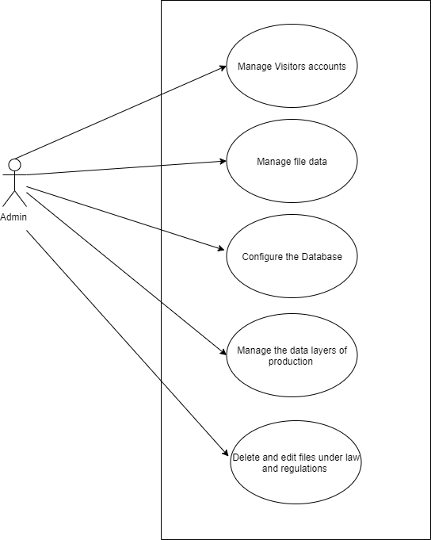

System Overview

Description

|  |
| --- |
| KEY SOFTWARE FEATURES |
| DASHBOARD |
| Manage Account |
| * Edit credentials |
| Reports |
| * Number of reports * On deck Reports |
| Knowledge Centre |
|  |
| Help Desk |
|  |
| KEY SECIRUTY FEATURES |
| Software Security |
| * Receive two factor authentication code |

System Architecture

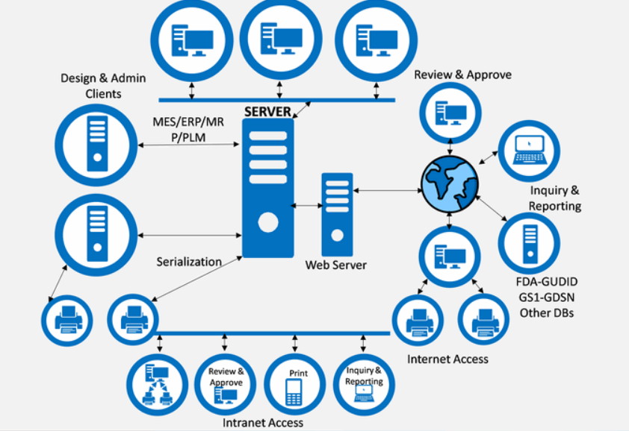

* Our system consists of HFS servers using APIs or integration, our system is robust and can take any amount of throttling given on the architectural side view, the more our system has QC on the every folder uploaded and download that will mean we have a redefined system that has an interconnected (Intranet) for easy management and security.

Architectural Activities

Financial Implications

Android tools

• Latest version of JDK

• Android SDK

• Apache Ant(Another Neat Toll) – an open-source tool that automates aspects of the Android build process

• Gradle – An advanced build toolkit that manages dependencies and allows you to define

custom build logic

Windows Desktop tools

Incomplete

Web Application Architecture

Hardware Architecture

|  |  |
| --- | --- |
| CPU | Intel core 1.60Hz or more |
| Memory | 2GB or more |
| Storage | ? GB |
| Operating System | Microsoft Windows 7/8/8.1/10 (32bit / 64bit) |
| Display |  |

Hardware Design

**Computer Systems**

The e-Police management will run on both android and the web.

**Hardware Components Peripherals**

|  |  |
| --- | --- |
| Input | * Keyboard * Computer mouse * Image scanner |
| Output | * Printer * Display screen |
| Storage device | * Flash drive * Hard disk drive |
| Input/output | * Network interface controller |

**Networks**

|  |  |
| --- | --- |
| Routers |  |
| Switch |  |
| Hub |  |
| Gateway |  |
| Bridge |  |
| Repeater |  |
| Modem |  |

Data and Database/Files

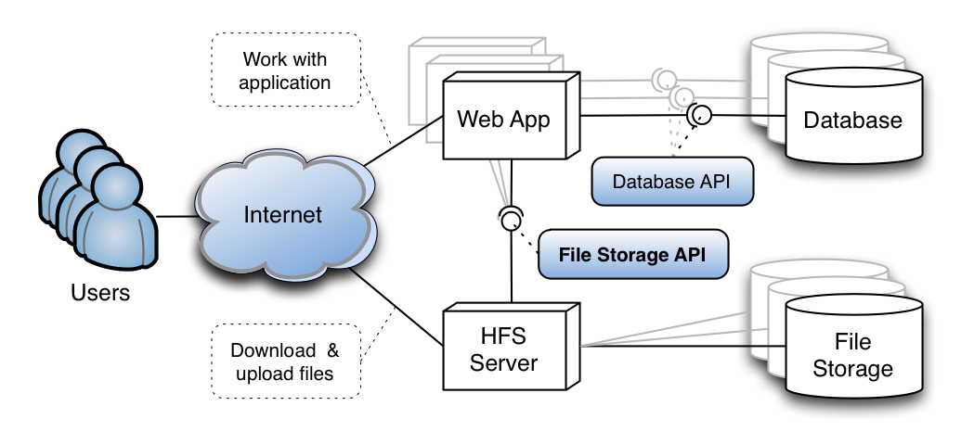

* On our database, our files will be stored via the internet, they can either be downloaded or uploaded, the uploading of file information may be done by the administration or the front end workers together with the clients, the downloading of files can only be done by circle detectives and administrators for legal usage, we going to use unified file storage APIs.
* We not going to save our files within application servers so we going to use one local server to broadcast our data, that way our data will be scattered into two which means automatically the other one falls under a backup stats.
* For the reason of HFS Server
* Our downstream and upstream is provided
* Can handle any traffic, we have more than 100 police stations in south Africa and we have more than 4 million people HFS server are able to handle a half of south African residents who are reporting at the same time, our HFS server are well equipped to provide scalable database file storage connecting both of our applications connected to the database

Dataflow Diagram

System Design

* **User Experience (UX) – Wireframes**
* **User Interface (UI)**